# Our Motivation:

To reduce the repercussions of patient no-shows, we have implemented a new patient engagement platform built on Pega Infinity. This solution helps to predict no-show appointments for clinical trials, primary care and even specialty medical appointments powered by Pega self-learning adaptive AI models.

This platform also helps to reduce physical interactions complemented with digital contactless collaboration and personalize all patient communications based on individuals' health conditions, medications with auto reminders.

**1. Importance of patient engagement platform:**

* In today’s world, patients are far too occupied to have time to wait around for the services that they do not need. There are significant number of patients who would no-show for their scheduled visits or do not respond to the automated telephone call to cancel their appointments. Based on a recent study, one out of every five patients who schedule an appointment do not show up. Every time a person skips their appointment, the healthcare industry endures a financial loss and patients miss out on receiving the treatment they need.
* In just a matter of four months as the COVID-19 pandemic spread across the world, it has stretched healthcare infrastructure of even the most developed countries. The rapidly increasing demand on health facilities and health care workers threatens to leave some health systems overstretched and unable to operate effectively.

**How this is Built?**

* **Predict No-Show Appointments:** AI is becoming a critical component for every industry. We have leveraged Pega Self-learning adaptive models that can suggest No-Show propensity by taking decisions in real-time. We have defined set of predictors based on data sets and designed an interactive mobile app to feed the data to train our models.
* **Contactless Virtual Appointments:** Virtual consultation through skype that take place between patients and doctors via communications technology — the video and audio connectivity that allows “virtual” meetings to occur in real time, from virtually any location.
* **Patient Centric Safe Hands Mobile App:** Now a days, Mobile apps become a primary way through which people patients contact hospitals. We have leveraged Pega Low Code mobile app builder to develop this Pega Mobile app.
* **Automated Personalized Reminders:** Designed a framework on top of Pega Notification Framework to send daily Prescription reminders and appointment notifications to accomplish critical health tasks. These reminders are typically sent to individual patients to independently perform health tasks.
* **Instant Collaboration Platform:** This feature facilitates collaboration and conversation among patients, doctors, and health care assistants. We have leveraged the out of the box Pega Pulse and Spaces to create patient groups to enable patients to post health related questions.
* **Data Sharing:** Data sharing is an option to send videos, files between hospital and their patient. Patient data may include information relating to their past and current health or illness, their treatment history, lifestyle choices and diet details. We have leveraged the Pega out of the box documents gadget to build a better alternative to emails as the data might contain PHI.

**What This Can Do?**

**1. Actors Involved:**

This platform involves Connecting patients, doctors, and staff on one single platform.

* **Health Care Assistant:**
* Initiates patient registration flow which onboards the patients into Safe Hands platform.
* Helps in resolving the question of the patients using collaboration platform.
* Create private patient groups for private conversations between doctors and patients.
* Get access to all the No-Show appointment dashboard charts.
* Helps patient engagement by sharing the health tips in the form of documents to patient groups.
* **Patient:**
* Schedule appointments through Safe Hands mobile app or web based platform.
* Post queries at anytime from anywhere using a collaboration platform.
* Gets personalized daily reminders of prescribed medicines based on the special instruction through our automated reminder framework.
* Gets access to the documents, health videos etc shared by the health care representative.
* Can change the notification preference at any time based on the choice.
* **Doctor:**
* Has a dedicated portal to access all the consultation requests.
* Can easily capture the symptoms and prescribe medicines from the application.
* Can also cancel the consultation if the patient has not attended the appointment requests.
* Also has an option to virtually assist patients through integrated video calling platform.
* Can help the patient in resolving their health-related questions through collaboration platform.

**2. Patient Registration:**

The process of patient registration starts with Health Care Assistant. Steps involved are as follows:

* Patient visits site/hospital in person.
* The Health Care Assistant at the registration desk assists the incoming patients. If the patient is new, health care assistant registers the patient by capturing his personal details, contact details and his health details.
* System automatically checks for the duplicate entries.
* If the registration is successful, stores the patient information into patient hub and the login details are sent to the contact info shared by the patient during registration.
* With the login details in hand, patient can either login to the safe hands mobile app or the desktop application to create appointments and other tasks.

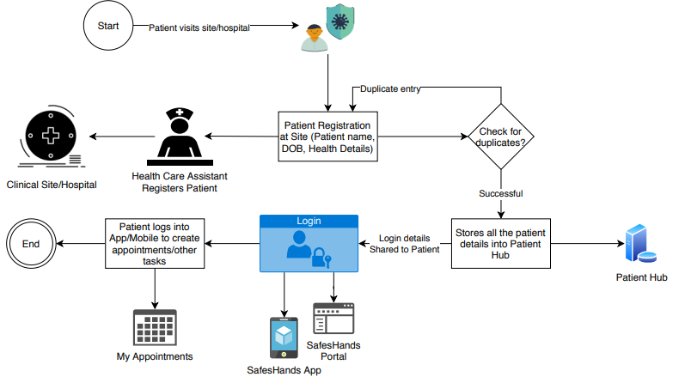

**3. Appointment Booking:**

The process of Appointment Booking starts with patient. Steps involved are as follows:

* After successful registration, patient can login to the safe hands mobile app or the desktop application.
* He / She have the access to view the scheduled, cancelled, completed appointments on login.
* Patient can schedule an appointment with the doctors of choice. He / She have a choice to schedule an appointment in the form of in person or virtual consultation with the doctor.
* Patient has the facility to cancel or reschedule the appointments booked.

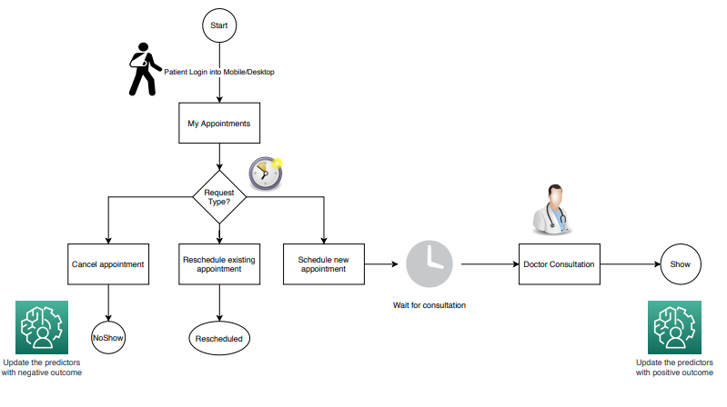

**4. Appointment predictors (Good to have):**

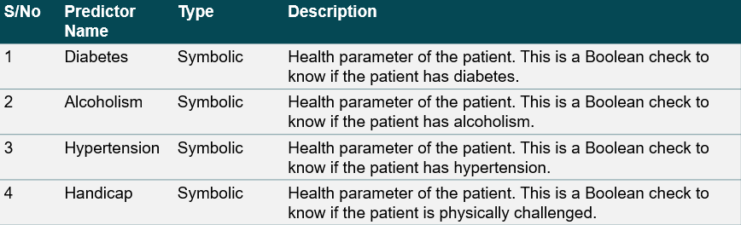

**5. Appointment No-Show predictors (Must have):**

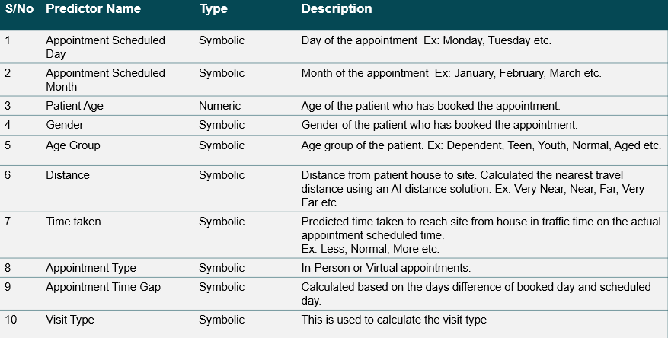

**Accomplishments We Are Proud Of:**

* **Pega 8.4 Community Edition:** Used most of the out of the box platform capabilities to build our micro journeys. Low code mobile development platform to build our patient centric app. Self-learning adaptive AI models to predict appointment cancellation or no-show probability using Pega Customer Decision Hub.
* **DistanceMatrix.AI (Free Trial):** To compute the distance and travel time between  
  points on a map with reliable and accurate APIs. This is used as a predictor for our self-leaning AI model which predicts appointment no-show.
* **Font Awesome:** Icons are an essential part of many user interfaces, visually expressing objects, actions, and ideas. We believe that great icons can also affect in user experience. To leverage hospital or patient specific icons we have leveraged free version of font awesome to meet our requirements.

# **Future Scope:**

For the upcoming year post covid19 pandemic, integrating this kind of Pega application with multiple strategic features can build a much stronger Customer Service with the most advanced Artificial Intelligence feature that Pega has offered to its client.

# **References:**

# **1. Url:**

<https://11b6anmn.pegace.net/prweb>

**2. Operator Logins:**

|  |  |  |  |
| --- | --- | --- | --- |
| **Role** | **Operator** | **Password** | **Description** |
| Administrator | SafeHandsAdmin | rules | Admin access to SafeHandsApp application. |
| HealthCareStaff | HealthCareStaff | rules | HealthCare Staff user for Safe Hands application. This user will onboard patient into Safe Hands application. |
| Doctor 1 | Doctor_general | rules | Doctor with general skillset. This operator handles all the general appointments. |
| Doctor 2 | Doctor_neuro | rules | Doctor with neuro skillset. This operator handles all the neuro appointments. |
| Doctor 3 | Doctor_cardio | rules | Doctor with cardio skillset. This operator handles all the cardio appointments. |
| Test Patient | SafeHandsPatient1@gmail.com | 1234qwer$ | Onboarded by Health care staff. |

**3. Update Dynamic System Settings:**

|  |  |  |
| --- | --- | --- |
| **Name** | **Ruleset** | **Purpose** |
| DefaultSiteAddress | SafeHands | This contains default site address. |
| DefaultTimeZone | SafeHands | This contains default time zone of the location where you want test this solution. |
| DistanceMatrixAPIKey | SafeHands | This contains the default distance matrix API key of 7 days free trial. |

**4. Business rules to update the distances:**

|  |  |  |
| --- | --- | --- |
| **Name** | **Ruleset** | **Purpose** |
| GetDistanceTypes | SafeHands | Calculate the distance category which is used as an input to the AI model. |
| GetTimeTakenInTrafficType | SafeHands | Calculate the time taken in traffic which is used as a predictor in AI model. |